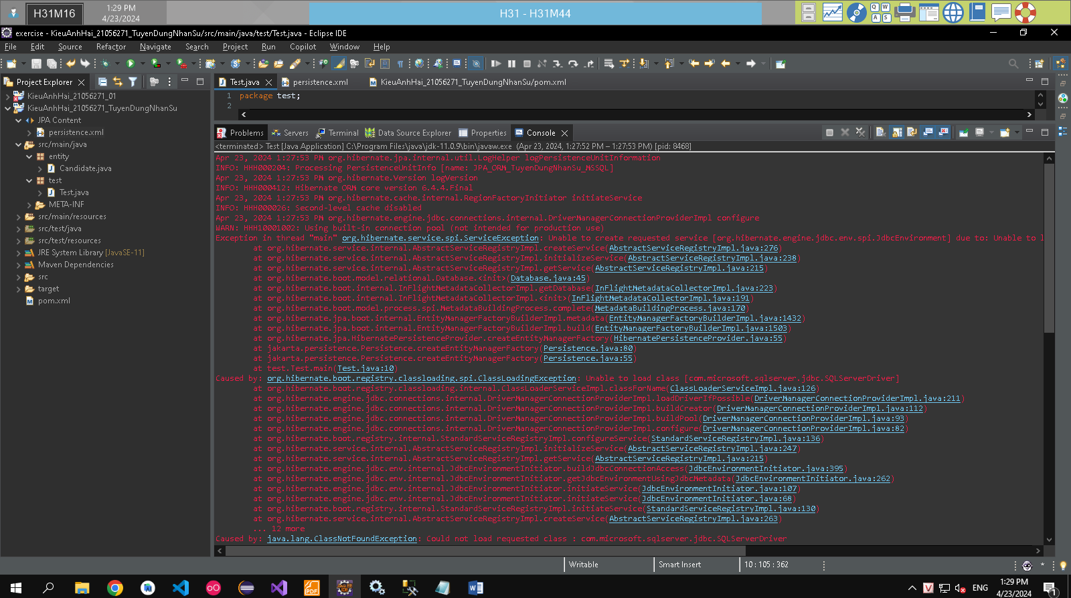

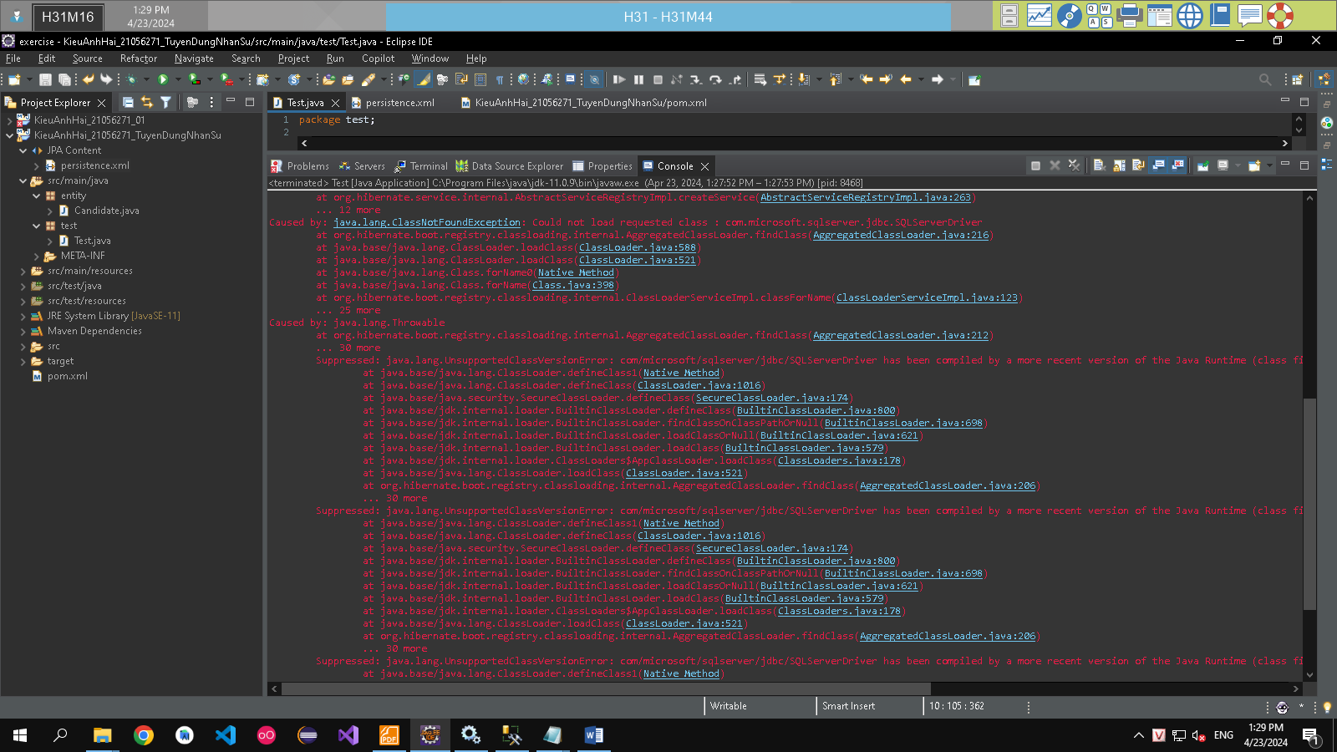

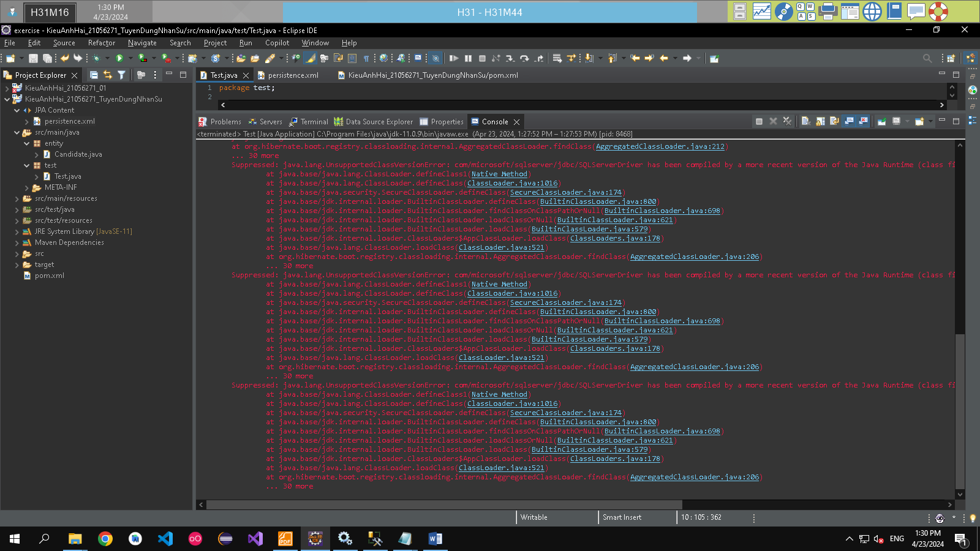

|  |
| --- |
| Apr 23, 2024 1:27:53 PM org.hibernate.jpa.internal.util.LogHelper logPersistenceUnitInformation  INFO: HHH000204: Processing PersistenceUnitInfo [name: JPA_ORM_TuyenDungNhanSu_MSSQL]  Apr 23, 2024 1:27:53 PM org.hibernate.Version logVersion  INFO: HHH000412: Hibernate ORM core version 6.4.4.Final  Apr 23, 2024 1:27:53 PM org.hibernate.cache.internal.RegionFactoryInitiator initiateService  INFO: HHH000026: Second-level cache disabled  Apr 23, 2024 1:27:53 PM org.hibernate.engine.jdbc.connections.internal.DriverManagerConnectionProviderImpl configure  WARN: HHH10001002: Using built-in connection pool (not intended for production use)  Exception in thread "main" org.hibernate.service.spi.ServiceException: Unable to create requested service [org.hibernate.engine.jdbc.env.spi.JdbcEnvironment] due to: Unable to load class [com.microsoft.sqlserver.jdbc.SQLServerDriver]  at org.hibernate.service.internal.AbstractServiceRegistryImpl.createService(AbstractServiceRegistryImpl.java:276)  at org.hibernate.service.internal.AbstractServiceRegistryImpl.initializeService(AbstractServiceRegistryImpl.java:238)  at org.hibernate.service.internal.AbstractServiceRegistryImpl.getService(AbstractServiceRegistryImpl.java:215)  at org.hibernate.boot.model.relational.Database.<init>(Database.java:45)  at org.hibernate.boot.internal.InFlightMetadataCollectorImpl.getDatabase(InFlightMetadataCollectorImpl.java:223)  at org.hibernate.boot.internal.InFlightMetadataCollectorImpl.<init>(InFlightMetadataCollectorImpl.java:191)  at org.hibernate.boot.model.process.spi.MetadataBuildingProcess.complete(MetadataBuildingProcess.java:170)  at org.hibernate.jpa.boot.internal.EntityManagerFactoryBuilderImpl.metadata(EntityManagerFactoryBuilderImpl.java:1432)  at org.hibernate.jpa.boot.internal.EntityManagerFactoryBuilderImpl.build(EntityManagerFactoryBuilderImpl.java:1503)  at org.hibernate.jpa.HibernatePersistenceProvider.createEntityManagerFactory(HibernatePersistenceProvider.java:55)  at jakarta.persistence.Persistence.createEntityManagerFactory(Persistence.java:80)  at jakarta.persistence.Persistence.createEntityManagerFactory(Persistence.java:55)  at test.Test.main(Test.java:10)  Caused by: org.hibernate.boot.registry.classloading.spi.ClassLoadingException: Unable to load class [com.microsoft.sqlserver.jdbc.SQLServerDriver]  at org.hibernate.boot.registry.classloading.internal.ClassLoaderServiceImpl.classForName(ClassLoaderServiceImpl.java:126)  at org.hibernate.engine.jdbc.connections.internal.DriverManagerConnectionProviderImpl.loadDriverIfPossible(DriverManagerConnectionProviderImpl.java:211)  at org.hibernate.engine.jdbc.connections.internal.DriverManagerConnectionProviderImpl.buildCreator(DriverManagerConnectionProviderImpl.java:112)  at org.hibernate.engine.jdbc.connections.internal.DriverManagerConnectionProviderImpl.buildPool(DriverManagerConnectionProviderImpl.java:93)  at org.hibernate.engine.jdbc.connections.internal.DriverManagerConnectionProviderImpl.configure(DriverManagerConnectionProviderImpl.java:82)  at org.hibernate.boot.registry.internal.StandardServiceRegistryImpl.configureService(StandardServiceRegistryImpl.java:136)  at org.hibernate.service.internal.AbstractServiceRegistryImpl.initializeService(AbstractServiceRegistryImpl.java:247)  at org.hibernate.service.internal.AbstractServiceRegistryImpl.getService(AbstractServiceRegistryImpl.java:215)  at org.hibernate.engine.jdbc.env.internal.JdbcEnvironmentInitiator.buildJdbcConnectionAccess(JdbcEnvironmentInitiator.java:395)  at org.hibernate.engine.jdbc.env.internal.JdbcEnvironmentInitiator.getJdbcEnvironmentUsingJdbcMetadata(JdbcEnvironmentInitiator.java:262)  at org.hibernate.engine.jdbc.env.internal.JdbcEnvironmentInitiator.initiateService(JdbcEnvironmentInitiator.java:107)  at org.hibernate.engine.jdbc.env.internal.JdbcEnvironmentInitiator.initiateService(JdbcEnvironmentInitiator.java:68)  at org.hibernate.boot.registry.internal.StandardServiceRegistryImpl.initiateService(StandardServiceRegistryImpl.java:130)  at org.hibernate.service.internal.AbstractServiceRegistryImpl.createService(AbstractServiceRegistryImpl.java:263)  ... 12 more  Caused by: java.lang.ClassNotFoundException: Could not load requested class : com.microsoft.sqlserver.jdbc.SQLServerDriver  at org.hibernate.boot.registry.classloading.internal.AggregatedClassLoader.findClass(AggregatedClassLoader.java:216)  at java.base/java.lang.ClassLoader.loadClass(ClassLoader.java:588)  at java.base/java.lang.ClassLoader.loadClass(ClassLoader.java:521)  at java.base/java.lang.Class.forName0(Native Method)  at java.base/java.lang.Class.forName(Class.java:398)  at org.hibernate.boot.registry.classloading.internal.ClassLoaderServiceImpl.classForName(ClassLoaderServiceImpl.java:123)  ... 25 more  Caused by: java.lang.Throwable  at org.hibernate.boot.registry.classloading.internal.AggregatedClassLoader.findClass(AggregatedClassLoader.java:212)  ... 30 more  Suppressed: java.lang.UnsupportedClassVersionError: com/microsoft/sqlserver/jdbc/SQLServerDriver has been compiled by a more recent version of the Java Runtime (class file version 64.0), this version of the Java Runtime only recognizes class file versions up to 55.0  at java.base/java.lang.ClassLoader.defineClass1(Native Method)  at java.base/java.lang.ClassLoader.defineClass(ClassLoader.java:1016)  at java.base/java.security.SecureClassLoader.defineClass(SecureClassLoader.java:174)  at java.base/jdk.internal.loader.BuiltinClassLoader.defineClass(BuiltinClassLoader.java:800)  at java.base/jdk.internal.loader.BuiltinClassLoader.findClassOnClassPathOrNull(BuiltinClassLoader.java:698)  at java.base/jdk.internal.loader.BuiltinClassLoader.loadClassOrNull(BuiltinClassLoader.java:621)  at java.base/jdk.internal.loader.BuiltinClassLoader.loadClass(BuiltinClassLoader.java:579)  at java.base/jdk.internal.loader.ClassLoaders$AppClassLoader.loadClass(ClassLoaders.java:178)  at java.base/java.lang.ClassLoader.loadClass(ClassLoader.java:521)  at org.hibernate.boot.registry.classloading.internal.AggregatedClassLoader.findClass(AggregatedClassLoader.java:206)  ... 30 more  Suppressed: java.lang.UnsupportedClassVersionError: com/microsoft/sqlserver/jdbc/SQLServerDriver has been compiled by a more recent version of the Java Runtime (class file version 64.0), this version of the Java Runtime only recognizes class file versions up to 55.0  at java.base/java.lang.ClassLoader.defineClass1(Native Method)  at java.base/java.lang.ClassLoader.defineClass(ClassLoader.java:1016)  at java.base/java.security.SecureClassLoader.defineClass(SecureClassLoader.java:174)  at java.base/jdk.internal.loader.BuiltinClassLoader.defineClass(BuiltinClassLoader.java:800)  at java.base/jdk.internal.loader.BuiltinClassLoader.findClassOnClassPathOrNull(BuiltinClassLoader.java:698)  at java.base/jdk.internal.loader.BuiltinClassLoader.loadClassOrNull(BuiltinClassLoader.java:621)  at java.base/jdk.internal.loader.BuiltinClassLoader.loadClass(BuiltinClassLoader.java:579)  at java.base/jdk.internal.loader.ClassLoaders$AppClassLoader.loadClass(ClassLoaders.java:178)  at java.base/java.lang.ClassLoader.loadClass(ClassLoader.java:521)  at org.hibernate.boot.registry.classloading.internal.AggregatedClassLoader.findClass(AggregatedClassLoader.java:206)  ... 30 more  Suppressed: java.lang.UnsupportedClassVersionError: com/microsoft/sqlserver/jdbc/SQLServerDriver has been compiled by a more recent version of the Java Runtime (class file version 64.0), this version of the Java Runtime only recognizes class file versions up to 55.0  at java.base/java.lang.ClassLoader.defineClass1(Native Method)  at java.base/java.lang.ClassLoader.defineClass(ClassLoader.java:1016)  at java.base/java.security.SecureClassLoader.defineClass(SecureClassLoader.java:174)  at java.base/jdk.internal.loader.BuiltinClassLoader.defineClass(BuiltinClassLoader.java:800)  at java.base/jdk.internal.loader.BuiltinClassLoader.findClassOnClassPathOrNull(BuiltinClassLoader.java:698)  at java.base/jdk.internal.loader.BuiltinClassLoader.loadClassOrNull(BuiltinClassLoader.java:621)  at java.base/jdk.internal.loader.BuiltinClassLoader.loadClass(BuiltinClassLoader.java:579)  at java.base/jdk.internal.loader.ClassLoaders$AppClassLoader.loadClass(ClassLoaders.java:178)  at java.base/java.lang.ClassLoader.loadClass(ClassLoader.java:521)  at org.hibernate.boot.registry.classloading.internal.AggregatedClassLoader.findClass(AggregatedClassLoader.java:206)  ... 30 more |